The following list includes resources that may be beneficial for children with autism during the COVID-19 school closures.

All families should prioritize any individualized work and resources provided by their child’s school. All resources listed here are meant to supplement any individualized activities and help children to follow a routine each day. These activities can be structured with the School Closure Toolkit.

Academic and Supplemental Websites
123HomeSchool For Me 101 FUN Things To Do During Coronavirus Lockdown
ABCya - Practice math and reading skills with games
Amazing Educational Resources - Alphabetical list of hundreds of websites with free subscriptions during school closures
Art Museum Coloring Books - 113 Art Museum Coloring Books available to download
Cassie Stephens - Daily video art lessons for art lovers!
CNN 5 Things You Need to Know Today - great for older students!
CNN News in 10 Minutes - sign up for daily emails - use this CNN10 Worksheet if appropriate
Fairfax County Public Schools Continuity of Learning Plan - Grades PK-12, all subjects
Go Noodle Brain Breaks - website with movement breaks of all kinds!
Highlights Kids - Stories, activities, science experiments
History for Kids - articles, worksheets, quizzes
Into the Book - Reading Strategy games for kids
Lalilo - Phonics program for kids
NatGeo Kids - Animals and geography for kids!
Raddish Kids Free Cooking Kit and Online Lessons ($4 shipping for cooking kit)
Scholastic News - Learn At Home - News, Articles, and Interactive Quizzes (PK-12)
Science Bob - Easy science experiments with videos and direction cards
Seussville - Dr. Seuss themed literacy games
Sped Adulting - Adulting made easy - life skills lessons and activities adapted for students with disabilities
StorylineOnline - Free children’s books read aloud with audio/video enhancement
Squiggle Park - Reading activities and games for ages 3-8
Switcheroo Zoo - Watch, listen, and play games with animals
Virtual Field Trips for Kids - over 30 virtual field trips!
Virtual Museum Tours - 12 museums around the world

Coronavirus Resources
BrainPop Coronavirus Video
BrainPop Coronavirus Materials
Cincinnati Children’s How Germs Spread Video - Great visual description for kids with autism
Handwashing Posters - 20 free Handwashing posters
Illinois Autism Partnership Coronavirus Social Story - help children understand school closures
Illinois Autism Partnership Social Distancing Story - help children understand social distancing
Nano Girls Why Do we Use Soap To Wash Our Hands - short informative video
STAR Autism Support Handwashing Resources - includes video model and printable visual supports

Curriculum Resources
Autism Helper - FREE 3 weeks of work packets
Boardmaker Activities to Go - FREE Special Education Curriculum Download (PK-12, adapted) - perfect to reinforce academic skills during academic time each day
EdHelper Daily Workbook Downloads - FREE leveled downloads DAILY for grades PK-6
Khan Academy - Free online lessons
Khan Academy Kids - Learning for ages 2-7
Math Help for Kids - Posted by EdHelper
Out of This World Literacy Workbooks - FREE Gr. 1-2 Workbook (3 weeks)
Out of This World Literacy Workbooks - FREE Gr. 3-4 Workbook (3 weeks)
Speech Therapy Homework - play based activities

Activity Resources
10 Ball Games for Kids
Animal Crawl Exercises for Kids with Videos
Art At Home (Art Activities)
Calm Down Jar
Fitness Activity Cards
Foam Dough

Apps
Kidoodle.TV - Fun and Safe Kids Shows

Facebook
Science Mom livestreams - M-F, 11-1PM EST, Ages 7-12
Music w/ Miss Liz livestreams - Early Childhood online music classes
Cincinnati Zoo Home Safari - Live, daily at 3PM EST
Cady Hickman, Theater - 10 AM EST, Circle Time for Early Childhood aged learners

Materials
Self-Adhesive laminating sheets - laminate those schedule pieces without owning a laminator!
Sensory Bin Kits - sets to create 4 different sensory bins
Velcro dots - great for schedules, token boards, and agendas while children are at home
Water beads - great sensory experience! (use caution with children who put items in their mouths) - will need a giant bin or bucket to put them in

YouTube
Alphabet Rock Song - a way to keep those letters in check!

Circle Time Hello Song - great way to get the day started for little ones
Circle Time Days of the Week Song - everyone’s favorite, very catchy!
Circle Time Months of the Year Song - learn those months!
Illinois Autism Partnership Circle Time Songs - a whole playlist of songs!
Illinois Autism Partnership Brain Break Songs - a whole playlist of brain breaks!
Mr. Calvin’s Art Room - Video art lessons
Uptown Funk Dance with Visual Supports - great for exercise, a fan favorite!

Other Schedule Ideas
Schedule Sample from EdHelper
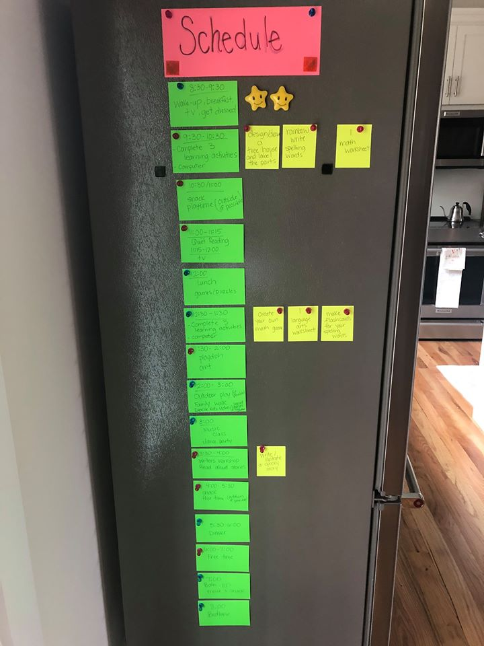
Index cards on the fridge with sticky notes for specific activities!

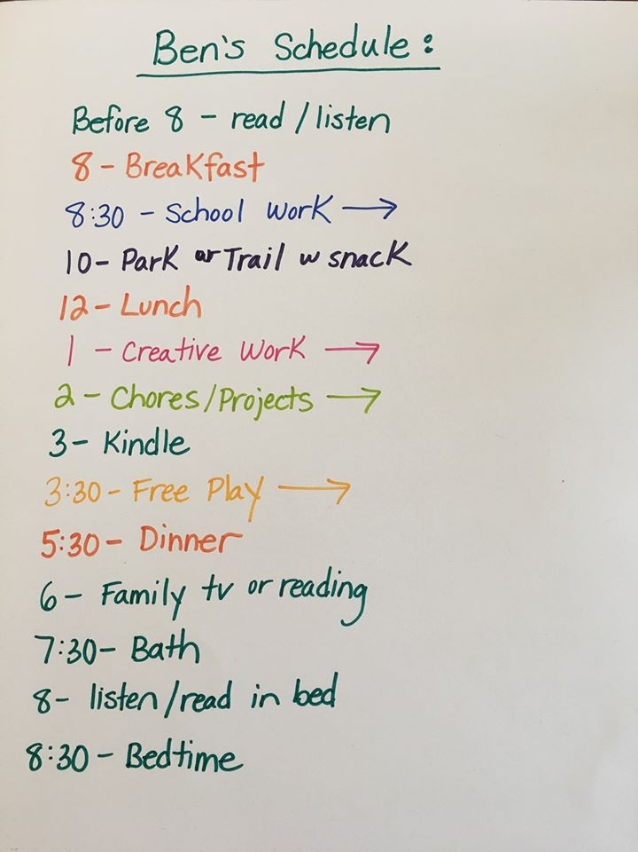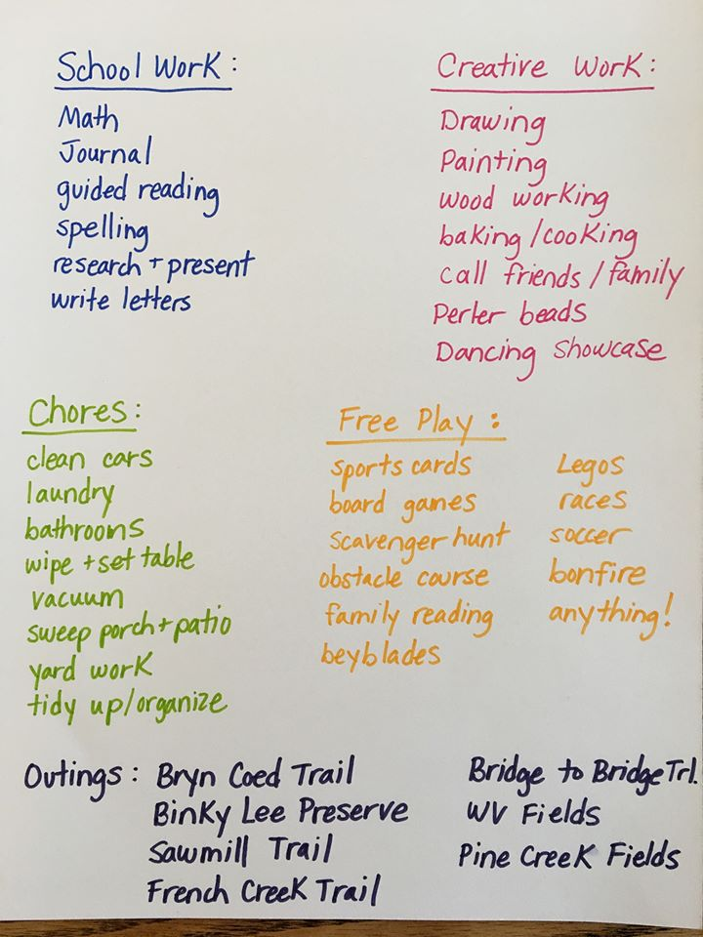
Simple dry erase board with color coding (just like ours!)

If you are accessing this document as a PDF,
CLICK HERE for the most up to date version online!

