Hi Zones Community! One of our most common questions is children’s book recommendation to introduce/reinforce concepts from The Zones of Regulation. Here is a list of books recommended by both our staff and our many friends on social media. Disclaimer: We have not read each and every book on this list, so please read for yourself before reading with your students.

*If you are PRINTING this list, you may want to download as a PDF first for better margins.

Have a recommendation? Fill out our survey, and we’ll add it to the list: Zones Book Survey

 | Title, Author | Cover | Recommended by- description
1 | "Chrysanthemum"  by Kevin Henkes | 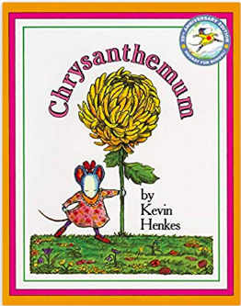 | Sarah Burke (Kindergarten inclusion teacher from Boston, MA)  “I use this book (and many other books by Kevin Henkes) when I’m teaching about the blue zone. The main character is teased by her classmates about her name which makes her feel sad. Her parents help her to feel better and get into the green zone.”
2 | “What Should Danny Do”  by Ganit and Adir Levy | 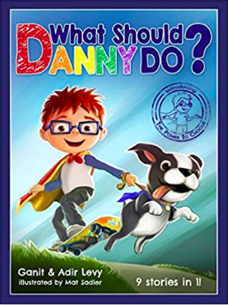 | Adina (School social worker from Michigan) “I have my students tell which zone each character is in, at different parts of the book. I also ask them to notice how the choices the characters make throughout the book (positive or negative), impacts which zone they move to.”  Susan Bertke (Kindergarten teacher from Ft. Recovery, OH) “I use it to teach students about how the choices they make can affect the way their day goes. The book has 9 different endings, depending on the choices the students make for Danny’s actions.”
3 | "Fergal is Fuming"  by Robert Starling | 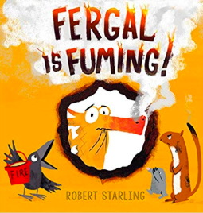 | Nerida Kiprotich (teacher from Hong Kong) “We use it to work it strategies to get back to the green zone”
4 | “Clark the Shark”  by Bruce Hale and Guy Francis |  | Leah Kuypers (creator of The Zones of Regulation from Minneapolis, MN)  “This book is great for the Yellow Zone, shows silly/impulsive behavior. The main character models using the tool of self-talk- rhyming- to help him manage his Zone.”
5 | "Potato Pants"  by Laurie Keller | 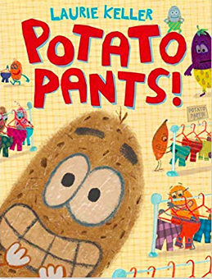 | Genny (school social worker from Woodridge, Illinois) “Zone identification, size of the problem”
6 | "The Way I Feel"  by Janin Cain | 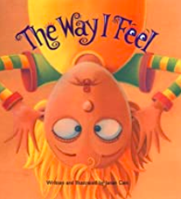 | Crystal Winters (school psychologist from Wichita, KS) ”I use this book as an introduction to emotions.”  Marci J (teacher from Tacoma, WA) “After reading the book, we go back through it and talk about what zone you might be in if you're experiencing the various emotions.”
7 | "We don’t eat our classmates!" by Ryan T. Higgins | 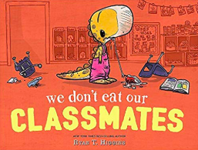 | Amy B (school psychologist) “This book helps reinforce the concept that all zones are ok and even the red zone can be expected in a given situation!”
8 | "Even Superheroes Have Bad Days" by Shelly Baker | 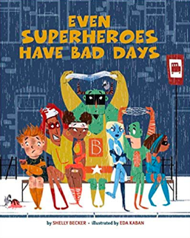 | Lauren Frydman (school counselor from Reno, NV) “I use this book to teach Expected vs Unexpected Behaviors”
9 | “How I act” by Janan Cain | 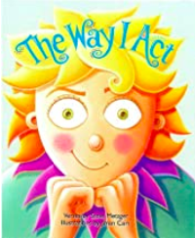 | Mrs. Jackman (2nd grade teacher)
10 | "No, No, Gnome"  by Ashlyn Anstee | 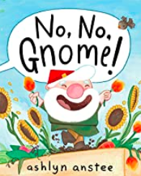 | Melanie Hartong (Occupational therapist from Cincinnati, OH) “The gnome in the story demonstrates very unexpected behavior.The gnome recognizes how his behavior impacts those around him, and works to take better care of those around him. The story is incredibly entertaining for young students, as it essentially walks them through a social behavior map.”
11 | “What if Everybody Did That?” by Ellen Javernick, Colleen M. Madden | 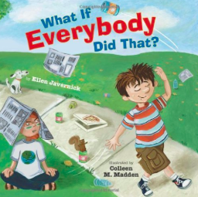 | Emily Walz (special education teacher, Zones content and social media from Minneapolis, MN) “I use this book to reinforce expected/unexpected behaviors and impacts of our behavior on others.”
12 | "I Can Handle It"  by Laurie Wright | 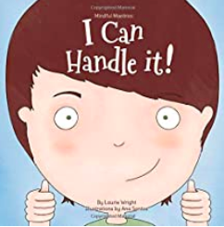 | Melanie Hartong (Occupational therapist from Cincinnati, OH) “This is a great quick book to reinforce size of the problem, and expected and unexpected reactions to problems.”
13 | "I Can Do That"  by Kayla Marnach | 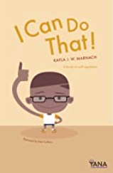 | Melanie Hartong (Occupational therapist from Cincinnati, OH) “This is a great book to reinforce the concepts that of tools, and the physiological sensations that can be indicative of a particular zone/emotion. “
14 | "Pete The Cat and his Magic Sunglasses"  by Kimberly and James Dean | 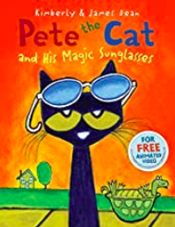 | (anonymous school counselor from Hayden, ID) “I use it to introduce the idea that we can group feelings into colored zones. While I read the book I jump into hula hoops on the floor that are the zones colors based on the feeling of the characters.”
15 | "The Pigeon HAS To Go To School!" by Mo Willems | 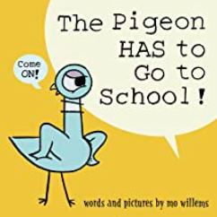 | Jenny Gilles (Music Educator and building Zones coordinator from Chardon, OH) “After reading the book, I ask the students to be Zones detectives and determine what Zone the Pigeon was in for the majority of the book (yellow). I also ask them to name a time when the Pigeon was in the Red Zone and the Green Zone.”
16 | "Llama Llama Mad at Mama"  by Anna Dewdney | 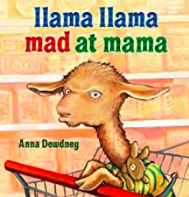 | Mrs. Fisher (special education teacher from Texas) “I use this book after introducing the different zones. The students are able to tell me which emotions are in each zone. While reading the book, I stop and have students help identify when the character moves from the green zone into other zones through the story.”
17 | "In My Heart: A Book of Feelings" by Jo Witek | 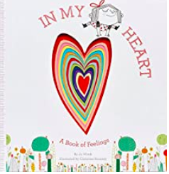 | Gee (Emotional Literacy Support Assistant (ELSA) from Surrey, United Kingdom) “I use this book to help children identify how their ‘feelings’ might feel in their own bodies”
18 | "My Friend is Sad" by Mo Willems | 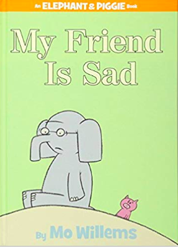 | Barb Casey (Principal from Walla Walla, WA) “I use this book to help young students understand the blue zone.”
19 | “The Invisible Boy” by Trudy Ludwig | 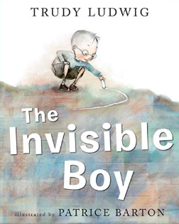 | Shantel Ducarme (school counselor from Calgary, Alberta, Canada) “I use this book with the lesson: Our behaviour Impacts the Feelings of Those Around Us. We discussed expected and unexpected behaviours and zones throughout the book. We also talk about how to change how the character feels in each scenario in the story - smiling at someone is this easy or hard - so easy! you can do this today. Afterwards I have students create notes or messages to change how someone feels and we hand them out throughout the school.”
20 | “How Do Dinosaurs Go to School?” by Jane Yolen | 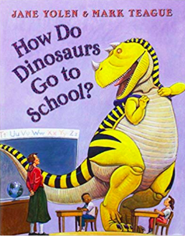 | Shantel Ducarme (school counselor from Calgary, Alberta, Canada) “I use this book reinforce the concept of expected and unexpected behaviours with kindergarten students.”
21 | “Ravi’s Roar” by Tom Percival | 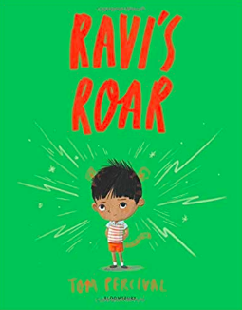 | Sophie from @_socialspeech_ (speech pathologist from Sydney, Australia) “I use this book to reinforce many of the Zones lessons. Ravi can control his temper but, one day, he lets out the tiger within (lesson 4: the Zones in me and lesson 9: triggers) But who wants to play with a growling, roaring, noisy, wild tiger who won't share or play nicely? (Lesson 5: social behaviour mapping) So Ravi has to calm down and let his tiger go (lesson 10).”
22 | “Ruby’s Worry” by Tom Percival | 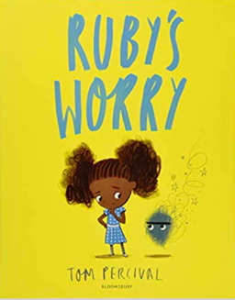 | Sophie from @_socialspeech_ (speech pathologist from Sydney, Australia) “I love this book to reinforce yellow zone emotions (worried, nervous) (Lesson 4: identifying emotions and lesson 6: me in my zones) I love how this book shows we all have worries from time to time and talking to others (lesson 12) is one tool we can use that can help ensure the worries don’t stay around too long.”
23 | “Today I Feel Silly and Other Moods that Make my Day” by Jamie Lee Curtis and Laura Cornell | 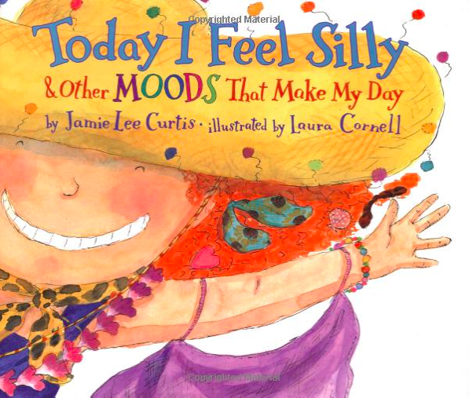 | Bridget Hand (School Counselor from Indianapolis, IN) “I use this book to identify the zone that each emotion described in the book is in. Fun book and they really enjoy associating it with the correct zone.”
24 | “Betty Goes Bananas” by Steve Anthony | 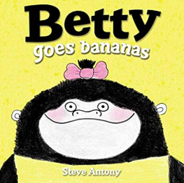 | Fiona (Psychologist) and Eve (OT) from Melbourne, Australia “Learning about feelings/emotions & that they come & go before introducing the Zones through Lessons 1-3 & 9... not a specific answer as some children ask for this book over & over... also an example of co-regulation…”
25 | “The Most Magnificent Thing” by Ashley Spires | 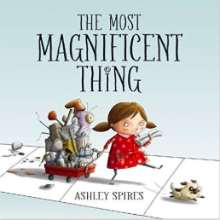 | Erin Spencer (School Social Worker from Cambridge, MA) “Identifying Zones, particularly the strategies the character uses to get back to Green Zone.”
26 | “I Like Myself” by Karen Beaumont | 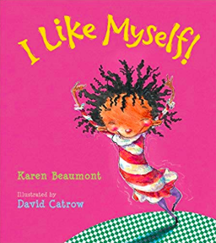 | Tracy Spain (School Counselor from MD) “I use this book to teach the green zone and being happy with who you are as a person.”
27 | “Worry Says What” by Allison Edwards | 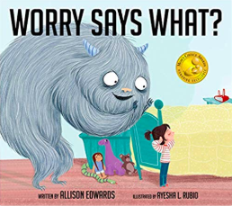 | Tracy Spain (School Counselor from MD) “This can be used to identify yellow zone feelings: Lesson 6 Me and My Zone. This story helps give students tools for dealing with worries. There is a song in the story that students can use to help silence the worries. This book can also be used when you discuss creating your own toolbox. Singing the song inside of your head can be a tool for dealing with worries.”
28 | “When Sophie Gets Angry- Really Really Angry...” by Molly Bang | 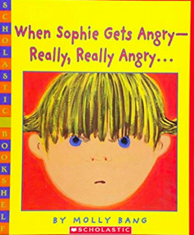 | Tracy Spain (School Counselor from MD) “I use this book to discuss triggers, calm down strategies for creating your tool box. At the end Sophie has painted a picture and this is an example of a calm down strategy, I like the way the author changes the outlining color around Sophie to show how her feelings changed throughout the story. This can also be used for Size of My Problem when addressing your reaction when things occur.”
29 | “Crankenstein” by Samantha Berger | 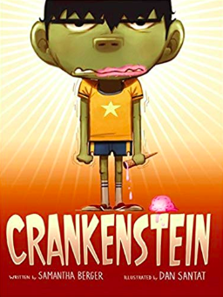 | Megan Marks (Speech and Language Pathologist from Plainfield, IL) “I love this book because it tackles many topics with Zones and Social Thinking. Students identify that Crakenstein is in the “Red Zone” and his triggers. This book is also great for Size of the Problem and understanding perspectives. After I read the book, we discuss our triggers and what makes us cranky. The students then me Crankensteins and write their triggers. “
30 | “The Good Egg” by Jory John and Pete Oswald | 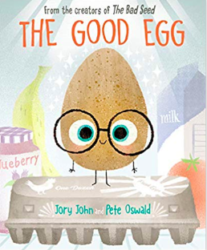 | Megan Marks (Speech and Language Pathologist from Plainfield, IL) “I use this book to help students identify triggers and tools. In this story the Good Egg gets stressed out by the other eggs in the carton and the need to be perfect. He ends up cracking under the stress. He leaves the carton and learns different tools to calm himself and heel his cracks. It is also great for students who have difficulty with mistakes and the need for perfection.”
31 | “Soda Pop Head” by Julia Cook | 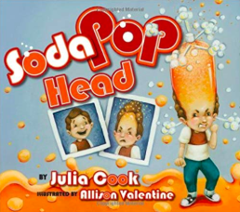 | Megan Marks (Speech and Language Pathologist from Plainfield, IL) “Lester has difficulty managing his anger and with problem solving. He learns tools to help him manage his anger and to move from the “red” to “green” zone. I love this book because it shows both the yellow and red zone. It also helps teach triggers and perspective. When Lester moves into the “red” zone, the other kids laugh and tease him. The art work also clearly illustrates moving between the Zones. “
32 | “A Little Spot of Sadness” by Diane Alber | 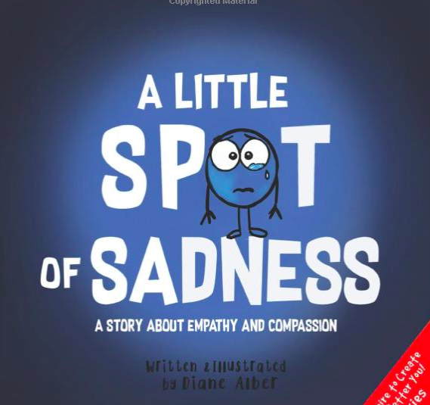 | Angel Holt (Kindergarten teacher in Austin, TX) “This book is great connecting to the blue zone and green zone (peaceful spot). Great author and will be buying more of her books!”
33 | “The Grumpy Monkey” by Suzanne Lang and Max Lang | 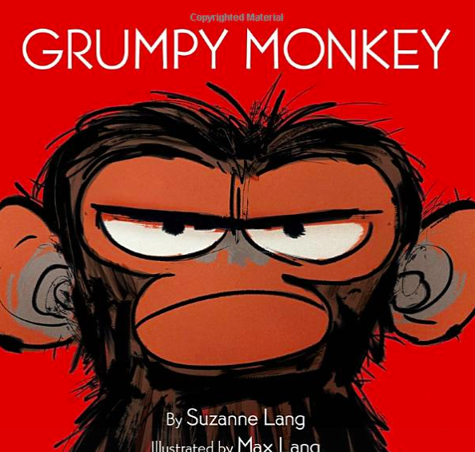 | Alanna (Social Worker from New York City, NY) “I use this book to discuss feeling in a bad mood (blue zone) and not knowing how to cheer yourself up. The monkey wakes up grumpy for no particular reason, and even though his friends offer to do his favorite activity with him to cheer him up, nothing cheers him up. At the end, sitting with his best friend makes him feel better. It helps guide my discussion by naming how other people feel, and identifying facial features that tell us someone is upset (or another feeling).”
34 | “Crickwing” by Jannell Cannon | 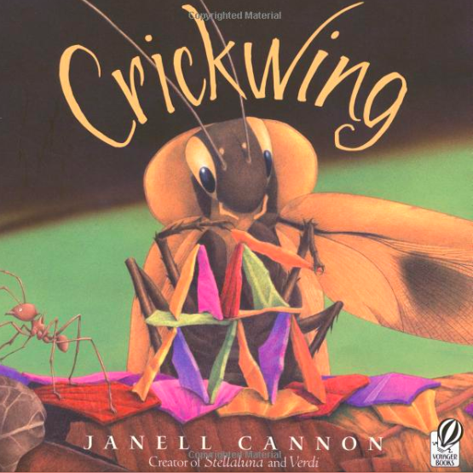 | Marte Scruggs (teacher from Lancing, TN) “I am teaching the zones in my room based on info that I can gather here and there. I happened upon Crickwing. It fits perfectly! Crickwing is a cockroach of the rainforest. His wing is broken and he is made fun of. He falls into a cycle of anger and begins to be a bully. A series of events help him see his behavior and he decides to change. My kids used zones language to retell the story. I hadn't even thought to do that. It was so natural and perfect.”
35 | “Listening to My Body” by Gabi Garcia | 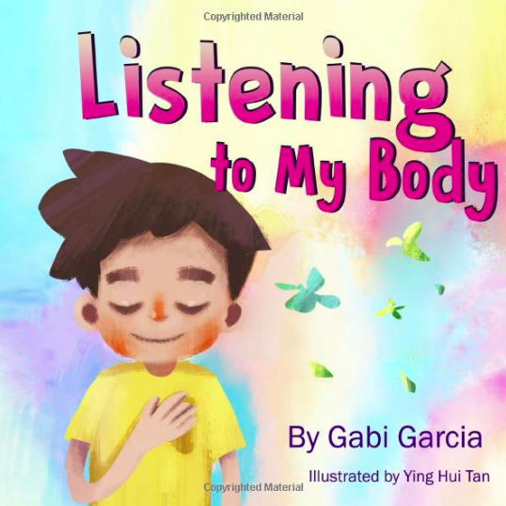 | Crystal Winters (School Psychologist from Wichita, KS) “Talking about how your body feels when you experience different emotions.”
36 | “The Color Monster” by Anna Llenas | 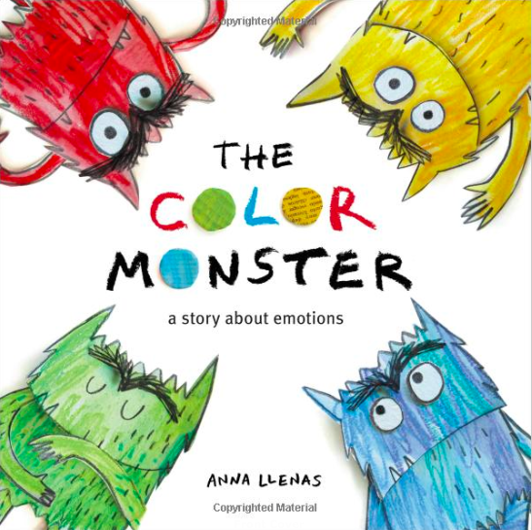 | Crystal Winters (School Psychologist from Wichita, KS) “I use this book to introduce emotions to students since so many of them only understand happy, sad or mad. We read this before even introducing Zones to give some foundational knowledge for them to build from.”
37 | “Visiting Feelings” by Lauren Rubenstein | 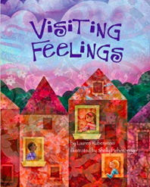 | Michele Dimon-Borowski (Autism Consultant from Auburn, NY) “This book encourages the reader to treat feelings as guests. I use it to talk about emotional awareness and that no feeling is a bad feeling.”
38 | “When I Feel Jealous” by Cornelia Maude Spelman | 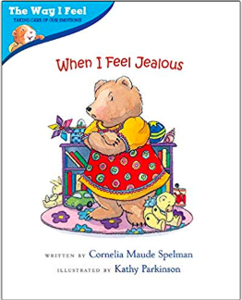 | Michele Dimon-Borowski (Autism Consultant from Auburn, NY) “I use this book to talk about the unpleasant feeling of jealousy and connect it to the yellow zone. The book also explains what children can do when they feel jealous so they have a tool to use.”
39 | “On Monday When It Rained” by Cherryl Kachenmeister | 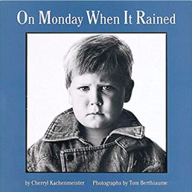 | Michele Dimon-Borowski (Autism Consultant from Auburn, NY) “I use this book to introduce a variety of emotions to students and tie the emotions to the corresponding zone. The book is set up with a scenario for each day of the week followed by how the little boy in the book feels. There are black and white photographs of how the boy looks when he is feeling each emotion.”
40 | “Cool Down and Work Through Anger” by Cheri J. Meiners | 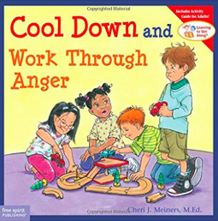 | Michele Dimon-Borowski (Autism Consultant from Auburn, NY) “I use this book to talk about anger and the red zone. Children learn that it is okay to feel angry but it is not okay to hurt anyone with actions or words. The book also provides ways to cope with one's anger.”
41 | "Giraffes Can't Dance" by Giles Andreae and Guy Parker-Reese | 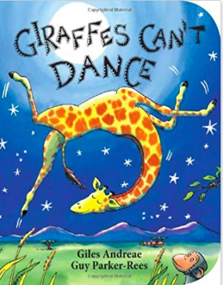 | Tania Rosa (Occupational Therapist from Providence, RI) “I use this book to discuss and show how we can experience so many emotions and move through the zones, as well as, discussing expected and unexpected actions and how others can impact and change our feelings/zones.”

